**Homework 2 Report**

-The code starts with importing pmatplotlib, numpy, and pandas.

-The code takes the image data and label data from excel, the image data is divided to train_set and test_set. The label data is first converted to int as “A”=1, “B”=2, “C”=3, “D”=4, “E”=5 and divided to train_truth and test_truth.

-Then the Y_truth array is created with hot-encoding by using train_truth label data.

-Sigmoid function is implemented to the code:



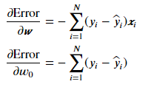-Gradient functions are implemented to code.

-Algorithm parameters are taken as eta = 0.01 and epsilon = 1e-3



-In iterative algorithm y_predicted is calculated with sigmoid function that defined before. Objective values are appended to new row in every iteration. W and w0 are calculated again in every iteration by reducing the error. The iteration continues until the error for old and new W and w0 is lower than 1e-3.

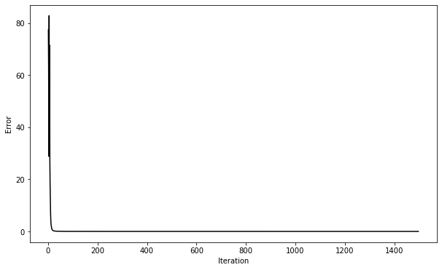-The convergence of Error with iteration times are plotted as follows:

-The confusion matrix is created for training set. The results are same for both prediction and truth values since it was for training gradients W and w0. The matrix is given below:

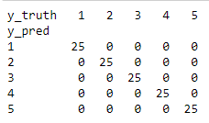

--The confusion matrix is created for test set. The results are not same for prediction and truth values since the prediction array used trained W and w0. So, the predictions are expected to have some error. The matrix is given below:

